Exact Predictions of Telco Customer Churn
(A Machine Learning Approach)

By
Marcel I Ngwueke

Springboard Data Science Career Track,
May 2021 Cohort
Capstone3 Project Report.

Table of Contents ii
1.0 Telco Customer Churn 1
1.1 Introduction 1
1.2 Study Review of Customer Churn 1
1.3 Problem statement 2
1.3.1 Business definition 2
1.3.2 Business Objective 2
2.0 Data Handling 3
2.1.0 Data Source and Structures 3
2.1.1 Data Cleaning and Wrangling 3
2.2 Feature Engineering 4
3.0 Exploratory Data Analysis – EDA 5
3.1 Distributions of Data Attributes 5
3.2 Distribution of Categorical Features by Churn Group 6
3.3 Probability Density Functions of Numerical Features 7
3.4 Distribution of Numerical Attributes by Churn Group 7
3.5 Correlation with Churn Rate and Histogram of Numerical Columns 8
4.0 Machine Learning Algorithms and Model Assessment. 10
4.1 Logistic Regression 10
4.2 XGBoost Classifier 16
4.3 Random Forest Classifier 22
4.4 Model Assessment 26
5.0 Discussion of Results 27
5.1 Conclusion 27
5.2 Recommendations 28
References 28

1.0 Telco Customer Churn
1.1 Introduction
Companies tend to lose their subscribers or customers to their competitors. It is prevalent that new customers of one company are churn rate from another organization. It implies that the loss of customers is usually a contribution of new customers to the other companies. Because of the high cost of acquiring new customers, most organizations endeavor to retain their existing customers or subscribers. This occurs especially in saturated industries like in the Telecommunication market, Banks, internet service providers, pay Tv companies, insurance firms, and alarm monitoring services.
There are two classifications of customer attrition. Voluntary churn rate and involuntary churn rate. The former happens based on a decision by a customer to migrate to another service provider company, while the latter is due to circumstantial relocation to a long-term care facility, death, or the relocation to a distant location. The latter class of churn rate is excluded from the analytical models. The demerit of churn rate is causing the value flowing from customers to the organizations to decrease. And if this issue persists the corporation will gradually relinquish its competitive advantage. In other words, loyal customers or subscribers help corporations reduce the cost of publicity and negotiation and can attract more new customers with a herd mentality, thereby minimizing customer development costs and increasing the opportunities and time for the companies to derive basic profits (Ming Zhao, et al 2021). Jones and Sassers (1995) demonstrated in their research paper, that if a company’s churn rate is decreased by 5%, the average profit rate of the company will jump by 25% - 85%. So Churn rate prediction brings economic benefits to organizations.
For enterprises or organizations to maintain and retain their customers’ subscriptions, they need to constantly evaluate their customers' databases to analyze which customers could churn. Therefore, the need for the application of Machine Learning Algorithms to exactly predict which of those customers has a high propensity to churn is essentially necessary for the success of such organizations. Models like Extreme Gradient Boosting Classifier, Logistic Regression, Random Forest Classifier, Support Vector Machine (SVM), GaussianNB, KNeighbor Classifier, and Decision Tree Classifier are used in customer churn predictions. In this investigation, three selected machine learning algorithms are applied to Telco customer churn datasets to determine which of these models would predict the exact number of customers who would churn. These are Logistic Regression, XGBoost Classifier, and Random Forest Classifier. Each of these models uses different hyperparameters that would give the accuracy of the model. It has been shown that mature markets with high teledensity have churn rates ranging from 1% to 2% per month, while high growth developing markets like India and China experience churn rates between 3% to 4% per month. Application of new technologies such as Machine Learning and Deep Learning churn prediction models coupled with effective retention programs, customer attritions could be better handled to reduce the significant financial losses from defecting customers.

1.2 Study Review of Customer Churn
In 2021, Lingling Yang, et al used Random Forest Classifier to predict Teleco customer churn in two months. Their choice of Random Forest Classifier was based on the model's ability to solve the non-linear separable problem with low bias and low variance and as well as handle high feature spaces and a large number of training examples. Aakash Dwivedi ( 2019) applied the method of customers segmentation to determine the factors responsible to churn in each customer segment. The paper constructed a churn prediction model that can identify customers likely to churn.
Abdeliahim Kasem Ahmad, et al (2019) developed a churn prediction model which can assist telecom operators to predict customers who are most likely subject to churn. The model uses Machine Learning techniques on the big data platform and created a new way of features engineering and selection. In addition to the Area under the curve (AUC), the paper introduces a new system to boost the AUC performance. This system is extracting social network analysis (SNA) features. Igbal Hanif ( 2019) demonstrates whether XGBoost is better than Logistic Regression in customer churn prediction, and he concluded that the XGBoost algorithm gives a better prediction than the Logistic Regression algorithm based on its prediction accuracy, specificity, sensitivity, and ROC curve. And the paper concludes that the XGBoost model has a better capability to separate churned customers from non-churned customers. Ming Zhao, et al (2021) provide answers to such questions as how customer attrition occurs, the influencing factors of churn rate, and how organizations win back churned customers.

1.3 Problem statement
1.3.1 Business definition
- Detect early enough which customers are about to leave and to have detailed information about them
- Ascertain the real value of the potential loss of those customers
- Which Machine Learning Algorithms would best detect the exact number of customers with a high-risk propensity to churn?
1.3.2 Business Objective
- Establish the casual factors to help organizations prevent customer attrition from occurring in the future.

2.0 Data Handling
This chapter exposes the data source, data cleaning, and data wrangling. The data must be in the proper format for machine learning algorithms can process them. The dataset is a combination of numerical variables and categorical variables. It’s in this chapter that the categorical variables would be transformed or converted to numerical values for the models.

2.1.0 Data Source and Structures
The data source is from the Kaggle: https://www.kaggle.com/blastchar/telco-customer-churn/

It contains 1 data file, which has 7043 rows and 21 columns.

The dataframe of the dataset was assigned and stored in df. This contains the names of the
following columns: customerID, gender, SeniorCitizen, Partner, Dependents, tenure, PhoneService, MultipleLines, InternetService, OnlineSecurity, OnlineBackup, DeviceProtection, TechSupport, StreamingTV, StreamingMovies, Contract, PaperlessBilling, PaymentMethod, MonthlyCharges, TotalCharges, and Churn.

Examination of the data structures and types shows that there are eighteen objects, one float, and two integers. Most of these object types are categorical variables and must be converted to numerical for machine learning models to use them.
2.1.1 Data Cleaning and Wrangling
Having identified the dataset variables to be of two classes: numerical and categorical. The categorical variables must be converted to numerical as stated earlier. Again, most datasets are known to have missing values or wrong data entries. In this investigation, none of the rows were dropped as a result of missing values. The only column that has some missing values and or is due to some rows containing string values is the ‘TotalCharges’. Applying the fillna function with column mean values restored the missing ‘NaN’ values.
2.2 Feature Engineering
To have some insights into the data, Machine Learning fits mathematical notations to the sets. Features are inputs to any model, and these features are numerical representations of an aspect of real-world datasets.
- The ‘TotalCharges’ column contains strings symbols, which made all the values to be nonnumerical and can’t be used for any computations. The column had to be processed by removing the strings.
- ‘SeniorCitizen’ column that was numeric had converted to object using Python dot astype function. This helps the categorical variables to be visualizable and readable.
- Applying sci-kit-learn library LabelEncoder to the dataframe df to convert nonnumerical labels to numerical labels. Seven columns were label-encoded after the process. The columns are gender, SeniorCitizen, Partner, Dependents, tenure, PhoneService, and PaperlessBilling.
- Then the remaining categorical variables are converted to dummy using Python get underscore dummies function with df as the argument.
- Variance inflation factor was used to check Multicollinearity that may arise due to LabelEncoder
- Next was to group the variables as target(Churn, the dependent variable) and non-target(independent variables). Then split the dataset for training purposes, using the target variable as the stratify parameter to resolve any class imbalance.
- Feature Scaling Manipulation: Applying sci-kit learn StandardScaler function on the training sets (X_train and X_test) to transform them have zero means and one standard deviation.

3.0 Exploratory Data Analysis – EDA
Python visualization techniques are used to examine the effects of some attributes on customer attrition. These attributes were created from the original dataset columns. Distributions and correlations would be presented in this section. However, the emphasis would be on churn, while the gender attribute is redundant.

3.1 Distributions of Data Attribute
The Churn column of the df dataframe has a total of 7043 rows with no missing values. The distribution according to the No and Yes categorical classifications shows that 73.5% are not churning while 26.5% are classified as churned. See figure 3.1, 5,174 for ‘No’ and 1869 for ‘Yes’. It is from this total that a prediction would be made. It is possible, that the models could predict a no-churn to be churn or a churn to be no-churn.

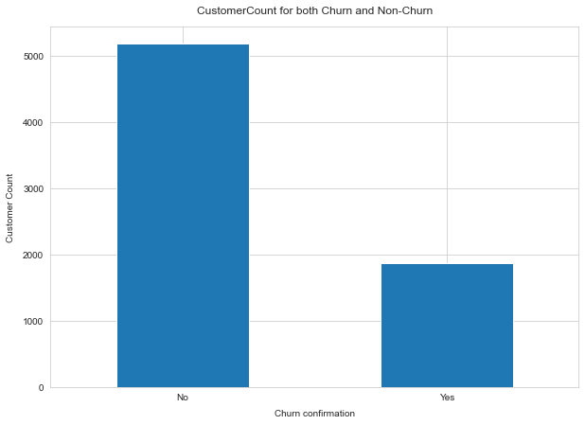
Figure 3.1: Target Variable distribution.

Some independent variables would not have any impact on the prediction of the customer churn rate. Gender is an attribution that would not affect the churning. Whether the subscriber is a male or female it would not affect the churn rate, see figure 3.2. And because it has no effect, it will be dropped from the Training Set. Data shows that about 27% of females churned and approximately the same percentage of males also churned.

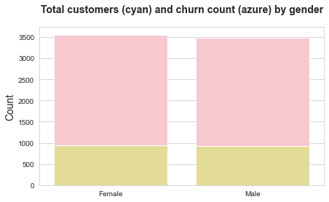
Figure 3.2: Gender distribution showing same characteristics for both male and female

3.2 Distribution of Categorical Features by Churn Group
As seen in figure 3.2 above, gender does not impact the churn rate. SeniorCitizen shows that 42% will churn while 24% won’t. For the Partner variable, with Partner, only 20% can churn while those without Partner will be 33% churnable. In the case of Dependents, no dependents have 31% churn and dependents have a 16% churn rate. See fig 3.3 below.

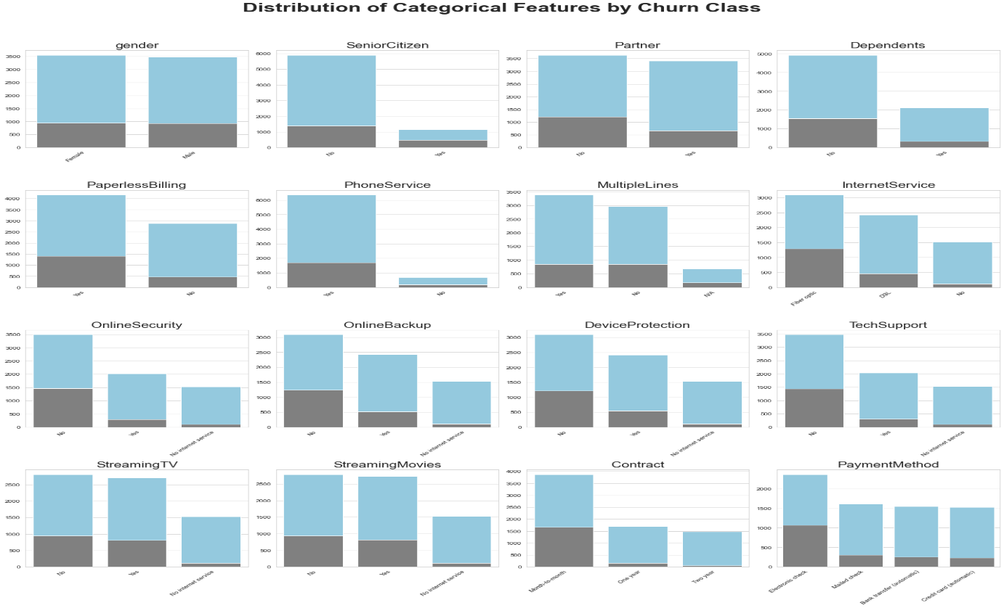
Figure 3.3: Distribution of categorical features by churn class
Internet services show that those subscribers with DSL will have 19% churn, fiber optics 42%, and no internet services 7%. Similarly, Onlinesecurity shows without 42% will churn, 7% for those without internet services, and 14% will churn even with onlinesecurity. For PaymentMethod, 17% churn for automatic bank transfer, 15% churn for credit card payment, 45% for the electronic check, and 19% for the mailed check. For the Contract variable, those who pay month to month will churn 43%, one year contract has 11% churn, and a 2-year contract will have a 3% churn.

In the case of OnlineBackup, those with no backup will churn 40%, no internet services 7%, and those with backup 22% churn. Similarly, DeviceProtection has 39% churn for ‘No’, 23% churn for ‘Yes’, and 7% churn for no internet services. TechSupport has 42% churn for ‘No’, 15% churn for ‘Yes’, 7% churn for no internet services. Those subscribers who don’t have StreamingTV 34& churn, those with StreamingTV 30% Churn, and no internet services 7% churn. And for PaperlessBilling, 16% churn for ‘No’, and 34% churn for ‘Yes’.

3.3 Probability Density Functions of Numerical Features
The Probability density function shows two peaks. The first peak indicates mostly new subscribers to the program while the second peak is those old customers who have stabilized in the system. The churn rate of these stabilized customers is very minimal. However, the danger is with the new customers that can churn at any time. These are the people the organization would target with incentives to make them stay.

MonthlyCharges appear bimodal, with two extreme points. Customers who spend less than 32 dollars and greater than 75 dollars. The probability density for TotalCharges shows customers are likely spending a relatively small amount than a high amount (see fig. 3.4)
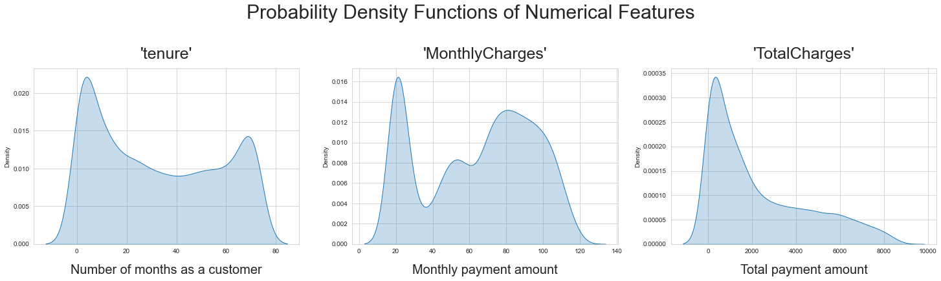
Figure 3.4: Probability Density Functions of Numerical Features

3.4 Distribution of Numerical Attributes by Churn Group
Fig 3.5 shows the distribution of numerical attributes by churn group, wherein in terms of tenure, customers who have been with the organization for a long period hardly churn, but those who are recent tend to churn more. TotalCharges shows that customers who have less total payment amount do churn.
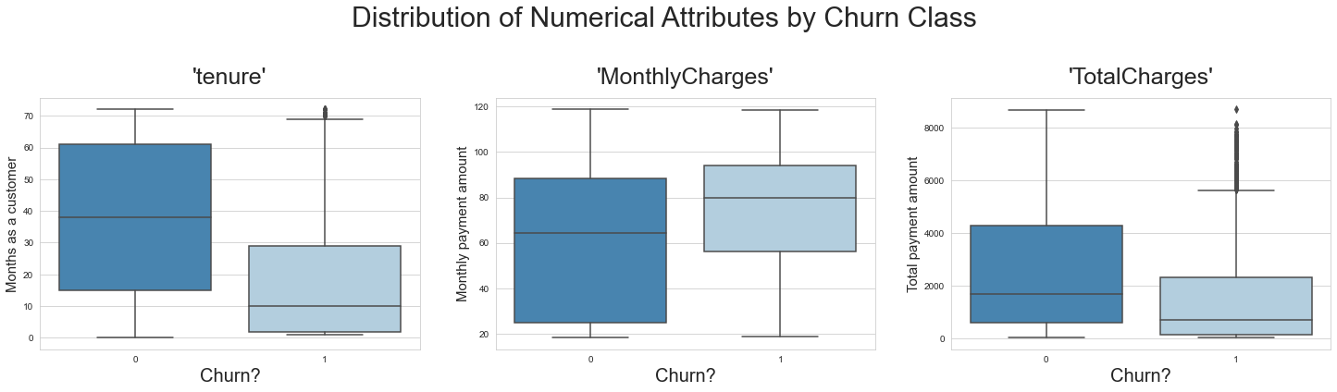
Figure 3.5: Distribution of Numerical Attributes by Churn Rate
3.5 Correlation with Churn Rate and Histogram of Numerical Columns
Gender distribution indicates a relatively equal proportion of male and female customers, that is 50% female and 50% male of the entire database. SeniorCitizen distribution shows that majority of the customers are young. Almost half of the customers have a partner. Also, like in the previous figure, tenure shows relatively new customers seen to have PhoneServices, and three-quarters of them use PaperlessBilling. See figure 3.6, MonthlyCharges shows the range of between 10 to 190, with most customers paying $20. The TotalCharges ranges from 0 to 8000 with most customers paying 20 to 3000 Dollars.

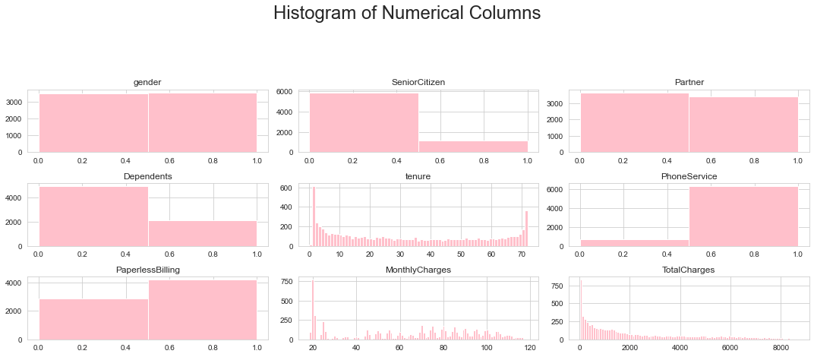
Figure 3.6: Histograms of Numerical Columns

Figure 3.7 shows the correlation of categorical attributes with a churn rate. The churn rate is impacted positively by SeniorCitizen, MonthlyCharges, PhoneServices, and PaperlessBilling. It implies that customer attrition increases with these variables. However, Partners, Dependents, tenure, and TotalCharges negatively relate to churn as shown in figure 3.7.

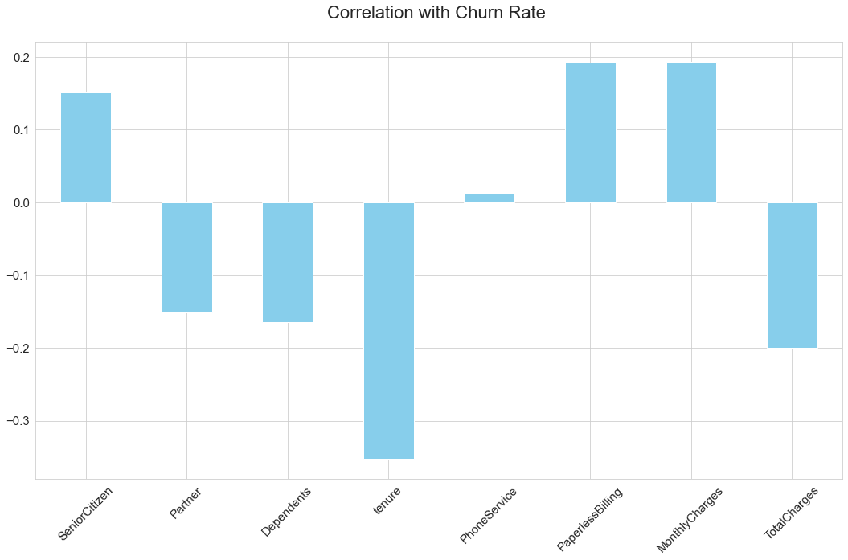
Figure 3.7: Correlation with Churn Rate.

4.0 Machine Learning Algorithms and Model Assessment.
Machine Learning Algorithms are classified into 4 types namely: Supervised Learning, Unsupervised Learning, Semi-supervised Learning, and Reinforcement Learning. Machine Learning is to model relationships and dependencies between a target prediction output and the independent features to predict the output values for new data based on the relationships learned from the previous datasets.

In Reinforcement Learning, the agent applies observations gathered from interaction with the environment to simulate actions that would maximize the reward or decrease the risk. This type of learning continuously iteratively learns from the environment.

Unlike Supervised learning, Unsupervised learning involves no assistance or supervision, and the system learns about patterns in a dataset. The algorithms try to use techniques based on the input data to mine for rules, detect patterns, and summarize and group the data points. The input data has no labels.

Semi-supervised Learning falls between Supervised and Unsupervised making use of both labeled training data and unlabeled training data, which would result in considerable improvement in learning accuracy.

In this study, Supervised Learning algorithms would be used. The first step was to subject the dataframe, df for training and validation by using the sklearn dot model underscore selection import train underscore test underscore split into X and Y variables. The X independent variable contains all the attributes of df with exception of the Churn which is the target variable. The Y then stores the target variable, Churn which would be predicted as a result of the effects of the independent variables in X.

4.1.0 Logistic Regression
One feature of Logistic Regression, as a predictive model, is its ability to perform a binary classification or predict ‘Yes/No’ or 1/0 type of output variable. It is a binary classification algorithm in the general class of the Linear Regression model. Logistic Regression can solve problems with more than two classes. In this investigation, Logistic Regression is used to create a model which is applied to the telco customer churn dataset, and use to predict if any particular subscriber of the set of customers will discontinue the service. Theoretically, the output or result of the Logistic Regression function is how the independent variables influence the probability of service discontinuation by the customer.

To evaluate the model after instantiating the Logistic Regression, the following conditions were applied for the regression: fit underscore intercept = False, C = 1e13, solver = liblinear. The model was fitted and later subject to prediction on the training dataset. The model was predicted based on the train and test sets. Next, was the model performance evaluation by determining the residual distance between the actual test data and predicted test data. These were accomplished by normalizing the amount of time the model was correct. Using sci-kit learn built-in functions, the model accuracy, precision, recall, f1 score, and f2 score were derived. These are 0.722, 0.487, 0.869, 0.624, and 0.751 respectively. Applying the KFold cross-validation on the model and training set with CV = 10, the Logistic Regression classifier accuracy was 0.70 +/- 0.03.

However, there is a need to determine the correct predictions and incorrect predictions. Sci-kit Learn built-in function called confusion matrix was called with actual values and predicted values (y_test and y_pred_test) as arguments. Fig. 4.1 indicates correct prediction (692 +325) and incorrect prediction (49 + 343).

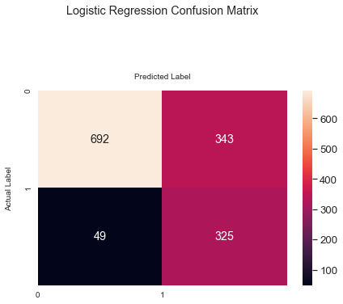
Figure 4.1: Confusion Matrix of the Logistic Regression Model

Employing the sci-kit learn ROC AUC score function, the ROC AUC curve of the test set for the Logistic Regression model was obtained. The value was calculated as 0.847, see fig.4.2.

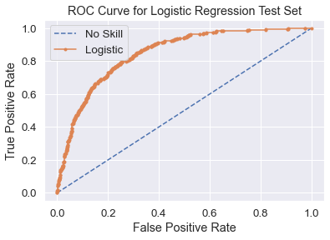
Figure 4.2: ROC Curve for Logistic Regression Test Set

4.1.1 Logistic Regression Hyperparameter Tuning
The Logistic Regression model’s performance was improved using Hyperparameter Tuning of the GridSearchCV method. List of penalty values, list of C-values, and solver were presented to the GridSearchCV and fit performed on the training set, which would select the best parameters to hyperparameter tune the Logistic Regression model. The best parameters include C= 0.01, penalty = 12, and solver = liblinear, which become the updated Logistic Regression model. Performing fit and predict on the train and test datasets, the test prediction probabilities were obtained. Fig 4.3 shows the results of the correct and incorrect predictions when the sci-kit learn confusion matrix was called with actual and predicted values as arguments. Correct (924 + 209) and incorrect (165 + 111) predictions with test accuracy of 0.8041. Table 4.1 shows a part of customerID, Churn, Prediction, the propensity to churn (%), and Ranking. It is not the entire prediction result.

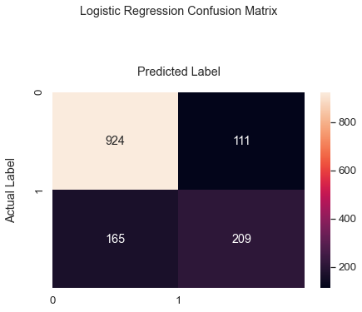
Figure 4.3: Confusion Matrix of Logistic Regression Model after Hyperparameter Tuning

The Churn column stands for the actual values in the dataset(telco customer churn), the prediction column is the model prediction of the churn based on the algorithm, propensity to churn, in percent stands for the customer inclination level to leave the enterprise and ranking stands for rating from 1 to 10.
Table 4.1: Logistic Regression Model Prediction ResultsUsing Hyperparameter Tuning 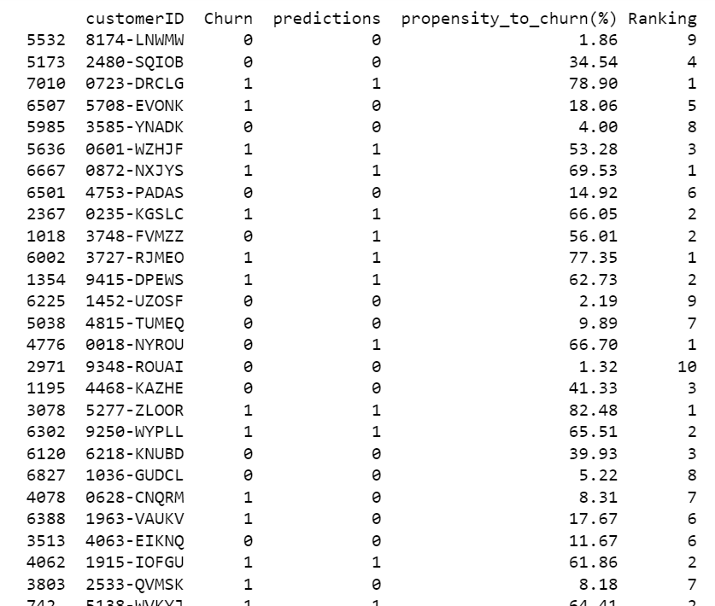

4.1.2 Shapley Interpretation of the Logistic Regression Model
Table 4.2: Corresponding Feature Names and their coefficients
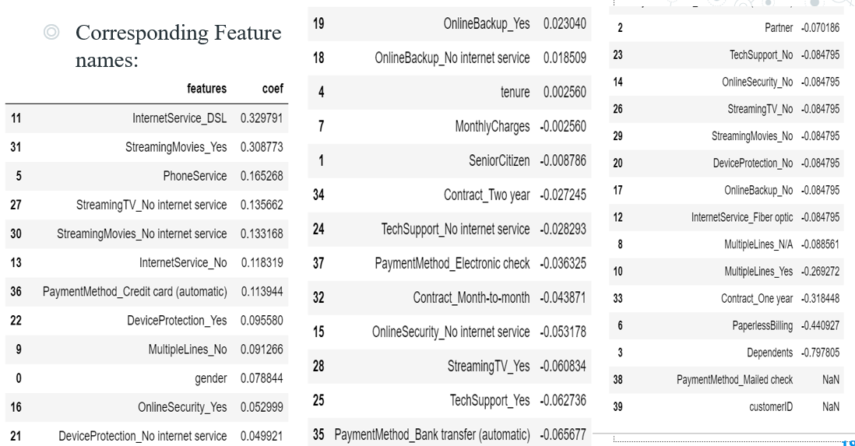
Table 4.2 is used to compliment fig 4.4, which is the shap feature importance associated with the Logistic Regression model. Dependents (3), PaperlessBilling(6), Contract_one year(33) and PaymentMethod( electronic card, 37) have negative effect on the churn prediction while, InternetService_DSL(11), StreamingMovies_Yes(31), Contract_Month-to-month(32) have positive contribution to churn prediction, see fig 4.4.

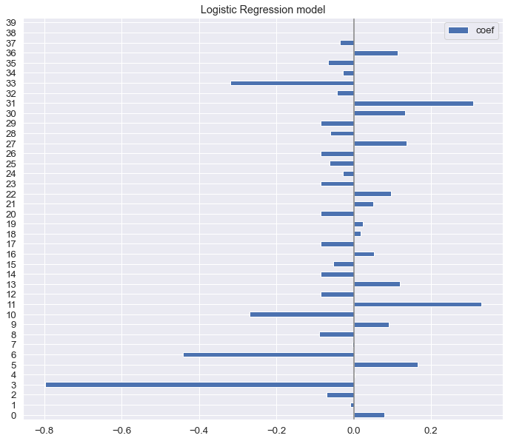
Figure 4.4: Feature Importance of Logistic Regression Model

Fig 4.5 resembles the feature importance mentioned above, however, it is the Shapley summary plot of the Logistic Regression model. The summary plot, in order words, combines feature importance with feature effects.
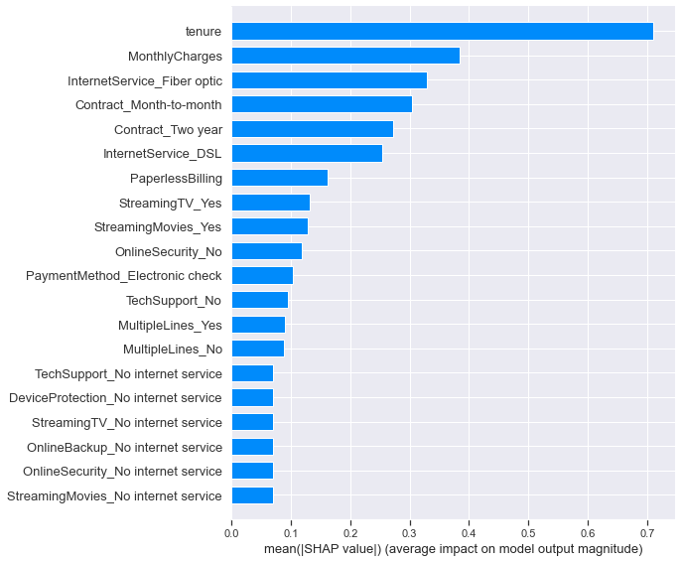
Figure 4.5: Summary Plot of Logistic Regression Model
On the y-axis, the features are ordered accordingly with their impact importance on the target variable. Tenure and MonthlyCharges are two features affecting churn prediction, see fig.4.6

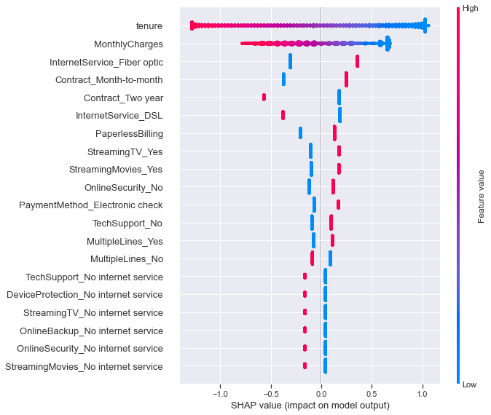
Figure 4.6: Shapley Summary Plot of Logistic Regression Model

Tenure has a high negative influence and a low positive effect on prediction. The same observation is seen in the case of MonthlyCharges.

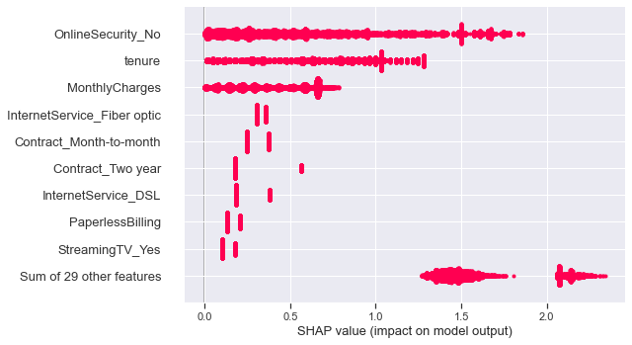
Figure 4.7: Shapley Plot Beeswarm of Logistic Regression Model

OnlineSecurity_No tops the list of three features affecting prediction. Tenure and MonthlyCharges, equally have a high impact on prediction as mentioned above. Fig 4.7 shows the three features from shap. Beeswarm plot, which depicts dense importance.

Shapley heatmap, fig.4.8, shows the function f(x) as the output of the Logistic Regression model and the global importance of each model input as bar plots which are the measures of overall importance.
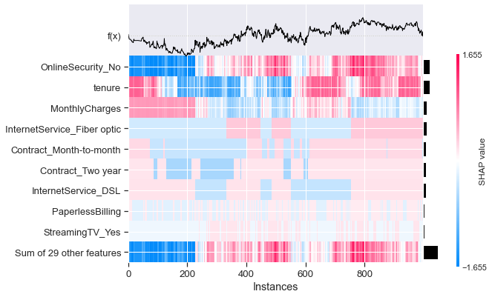
Figure 4.8: Shapley Heatmap plot of Logistic Regression Model
4.2.0 XGBoost Classifier Model
XGBoost is an ensemble tree method that uses the principle of boosting weak learners thereby implementing systems optimization and algorithmic enhancements. Extreme Gradient Boosting (XGBoost) is an effective open-source implementation of gradient boosting algorithms. The stochastic gradient boosting algorithms, also known as gradient boosting machines or Tree boosting, is a powerful machine learning technique that performs well or even best on a wide range of challenging machine learning problems. XGBoost model description includes, objective as binary: logistic, seed:42, and missing: 1. The next step was to instantiate XGBClassifier with the above params.
The xgb model was fitted and later subject to prediction on the training dataset (train and test sets) resulting in the training set accuracy of 0.838, test set accuracy of 0.799 and complete evaluation indicates the accuracy of 0.799, Precision 0.660, Recall 0.503, F1 score 0.571, F2 score 0.528.

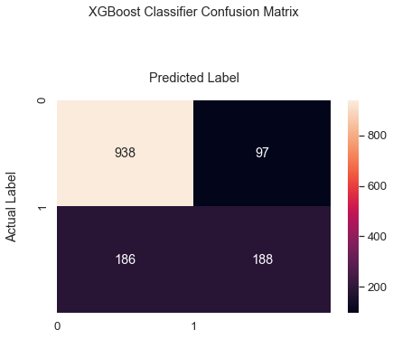
Figure 4.9: Confusion_matrix for xgb classifier Model

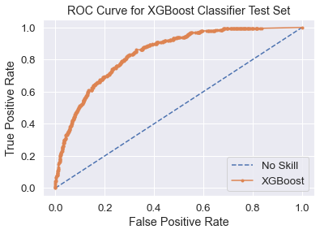
Figure 4.10: ROC AUC of the Test data for the XGB Classifier

However, there is a need to determine the correct predictions and incorrect predictions. Sci-kit Learn built-in function called confusion matrix was called with actual values and predicted values (y_test and y_pred_test) as arguments. Fig. 4.9 indicates correct prediction (938 + 188) and incorrect prediction (186 + 97). Fig 4.10 shows the ROC AUC curve of the test data derived from using the Scikit learn roc_auc score with some arguments, which is 0.799.
4.2.1 XGBoost Classifier Hyperparameter Tuning
XGBoost Classifier model performance was Hyperparameter tuned using GridSearchCV function from sci-kit learn, with several arguments including defined param grid, estimator, objective: binary: logistic, colsample_bytree = 0.5, n_job = 10, and scoring as ‘roc auc’. This GridSearchCV was fitted with the training set, with evaluation metric as auc, and evaluation set as a target and non-target dataset. The resulting accuracy for this hyperparameter was 0.850. Applying confusion matrix on the GridSearchCV model after fitting and predicting on the trained data set, using the actual values and predicted values as arguments to determine the correct prediction (744 + 305) and incorrect prediction (69 + 291), see fig.4.11

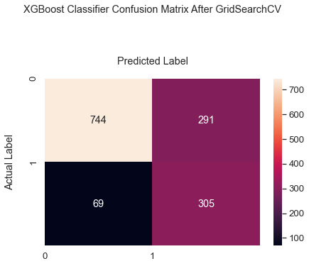
Figure 4.11: XGBoost Classifier Confusion Matrix after GridSearchCV

Table 4.2 shows a section of customerID, Churn, Prediction, the propensity to churn (%), and Ranking. It is not the entire prediction result. The Churn column represents the actual values in the dataset (telco customer churn), the prediction column is the XGBoost Classifier model prediction of the churn based on the algorithm, propensity to churn, in percent represents the customer inclination level to leave the organization and ranking represents rating from 1 to 10.

Table 4.2: XGBoost Classifier model Churn prediction, showing Churn, prediction, propensity, ranking
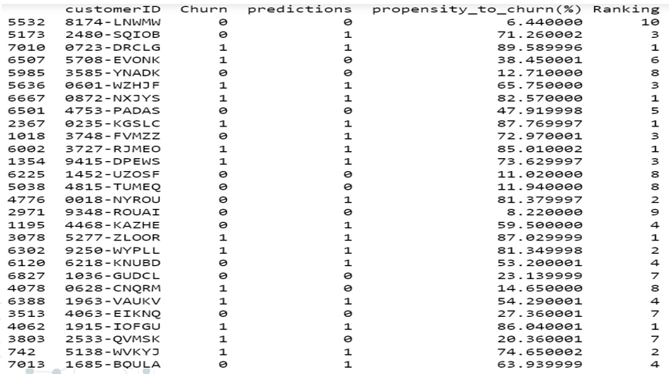

4.2.2 Shapley Interpretation of the XGBoost Classifier Model
Feature Importance for XGBoost Classifier shows that Contract_Month-to-Month effectively contributed to churn prediction or tendency that a subscriber would churn (fig 4.12).

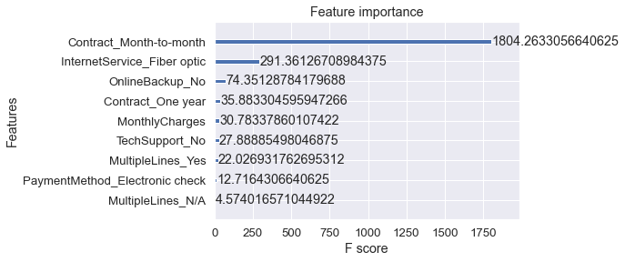
Figure 4.12: XGBoost Classifier Feature Importance
Also, subscribers who receive the InternetService_fiber optic are most likely to churn at a great rate as shown in the figure below. Those who don’t receive OnlineBackup_no and Contract_One year contribute too to churn prediction. Those numbers on the x-axis are the F score and the y-axis are the model features.

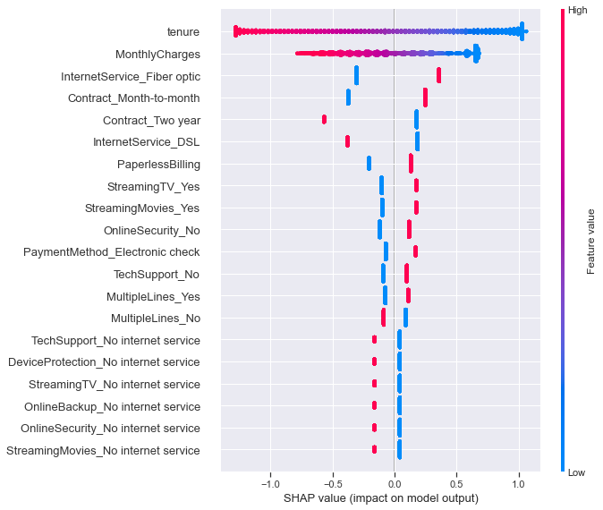
Figure 4.13: Shapley Summary plot for XGBoost Classifier Model (Train set)

Shown are two Shapley summary plots for train and test sets (fig 4.13 & 4.14) from the XGBoost Classifier. Fig. 4.13 indicates that tenure and MonthlyCharges have a high negative(red) and low positive (blue) Shap impact on the model output, the churn prediction.

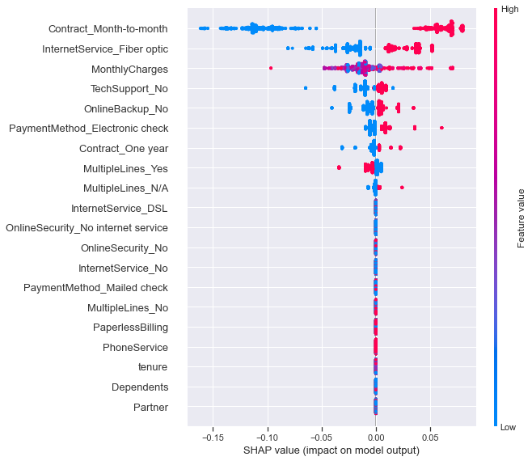
Figure 4.14: Shapley Summary plot for XGBoost Classifier Model (Test set)

Dependences Shapley plot of the MonthlyCharges shows a nonlinear relationship with the churn and it interacts with the feature Contract_Month-to-Month ( fig 4.15). Similarly, fig 4.16 shows summary plot interaction values with the features. Those with red color demonstrate a high impact on the output of the model, as blue color indicates the low impact on the prediction model output.
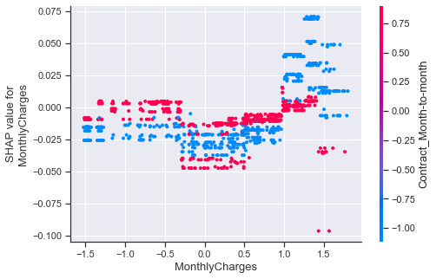
Figure 4.15: Shap Dependence plot for MonthlyCharges of XGBoost Classifier

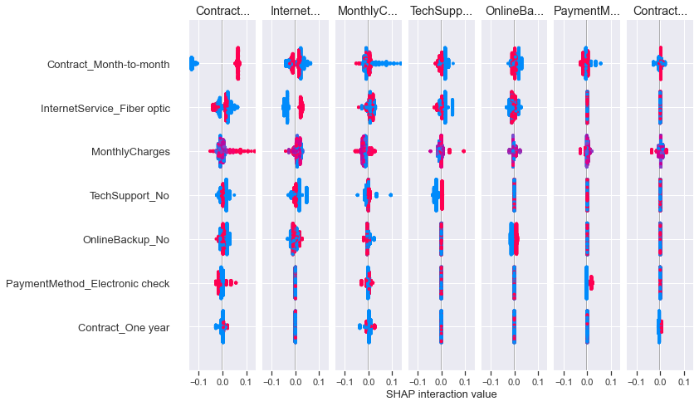
Figure 4.16: Shap Summary Plot Interaction Values for XGBoost Classifier.

E[f(x)] = 0.009 is the expected model output, the features with blue arrows show that they reduce the predicted probability of churning or customer attrition, that’s a negative (blue) contribution of each feature by moving the value from the expected model output over the background dataset to he model output for this prediction (see Fig 4.17).

The top figure of fig 4.18 shows the predicted values of -0.16 and it is below the base value of 0.009316. The result is due to the low impact of the following features Contract month to month, MonthlyCharges, InternetServices fiber optics on the prediction output. As shown on the bottom figure of fig 4.18, the output prediction is 0.07 much higher than the base value of 0.009316. While the InternetServices Fiber optic contributes low to the output prediction, MonthlCharges, PaymentMethod_Electronic check, OnlineBackup and Contract_Month-to-Month contributed to high impact to the final prediction.

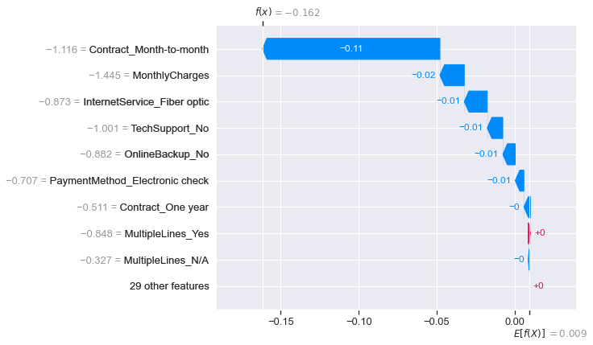
Figure 4.17: Shapley Waterfall plot for the XGBoost Classifier model

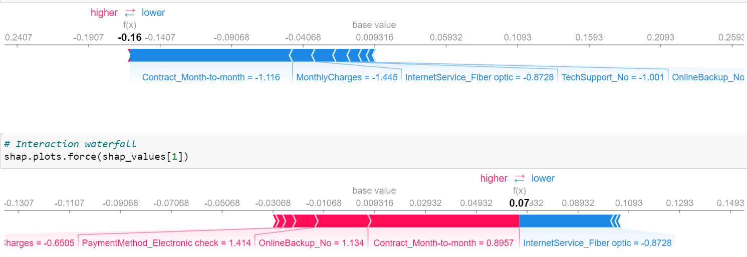
Figure 4.18: XGBoost Classifier model Shap plots force
4.3.0 Random Forest Classifier Model
Another popular Machine Learning Algorithm is Random Forest, which belongs to the supervised learning technique. It can be used to solve both classification and regression problems in machine learning. Random Forest is based on the concept of ensemble learning which combines multiple classifiers to solve a complex problem and enhance the performance of the model.
To apply Random Forest Classifier on Telco customer churn prediction, instantiate the classifier with the random state as an argument. Using this model to perform fit on the train set, had a training accuracy of 0.996 and test set accuracy of 0.773. With Scikit Learn inbuilt functions: accuracy, precision, recall, F1, Fbeta scores with arguments (y_tests and rfc predictions), the model evaluation are 0.773, 0.595, 0.452, 0.475 respectively. To confirm the model variance using KFold cross-validation to have classifier accuracy as 0.78 +/- 0.03.
Applying Scikit learn confusion matrix with y_test and rfc predictions as arguments, correct predictions (920 + 169) and incorrect predictions (205 +115) were derived see fig 4.19.
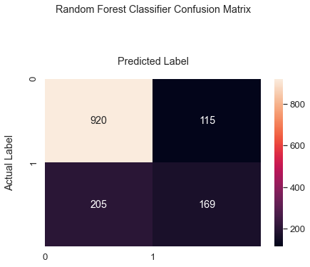
Figure 4.19: Random Forest Classifier Confusion Matrix
The ROC AUC function for the Random Forest Classifier model is shown as 0.816 for the Test set. See Fig. 4.20.
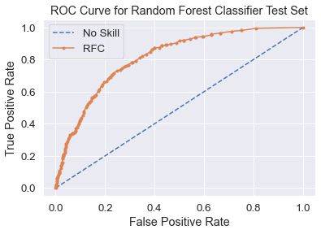
Figure 4.20: ROC AUC of Random Forest Classifier for Test set
4.3.1 Random Forest Classifier Hyperparameter Tuning
To improve the performance of the Random Forest Classifier, Hyperparameter Tuning with GridSearchCv with arguments like grid and cv = 5. The grid is a dict of values such as bootstrap : [True], ccp_alpha : [0.0], class_weight :[balanced, balanced_subsample], criterion:[gini, entropy]. Next was to fit the train and test sets with this new model and its best accuracy determined. After this, regularization hyperparameter values were assigned to the GridSearchCV and performed fit on the train and test sets. The final model uses the random state as zero, and criterion as ‘gini’, fit and predict on the train and test sets. The predicted values and actual values were used on the confusion matrix in which correct (929 + 170) predictions and incorrect (204 +106) predictions were determined (see fig.4.21)

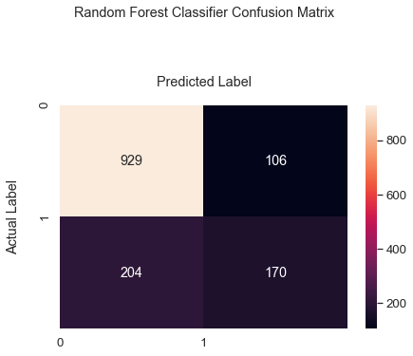

Figure 4.21: Confusion Matrix after Hyperparameter tuning of the model

Based on the results of predictions a table showing the actual and predicted values, propensity to churn, and ranking were presented in Table 4.2, which depict the actual churn values, predicted churn values with RFC, propensity to churn, and their rank from 1 to 10. Note that this is not the entire result of the RFC predictions.
Table 4.2: Results of the RFC Predictions showing predicted, propensity, and ranking
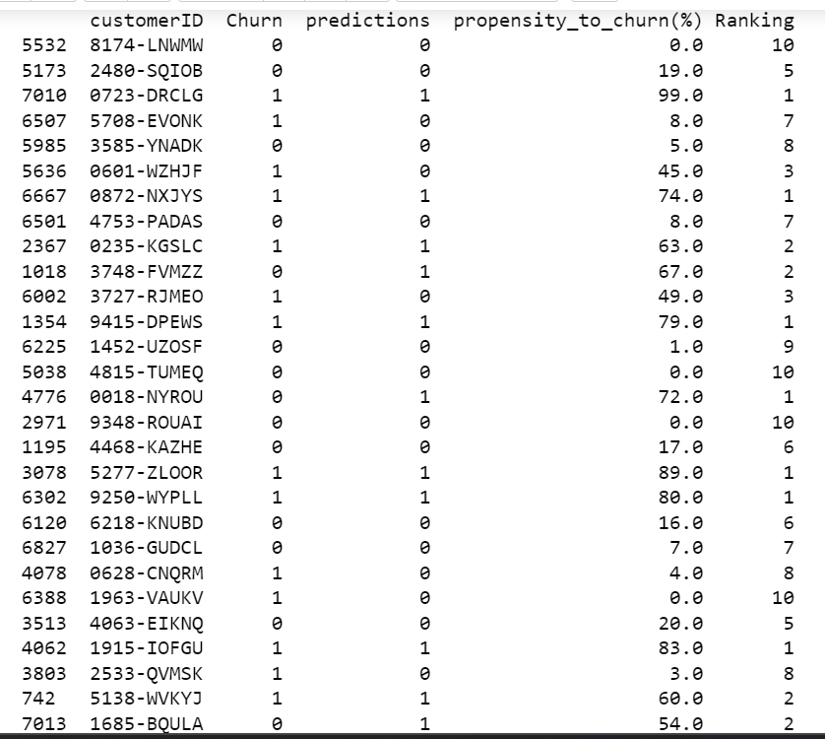
4.3.2 Shapley Interpretation of the Random Forest Classifier Model
Fig.4.22 is the Shap Summary plot for Random Forest Classifier and in this system is shown in two classes (0, 1). The first 3 features (tenure, contract Month to month, InternetService_ fiber optics) contribute to high output values in the prediction. The classes indicate both strong and weak impaction to the output of the model.

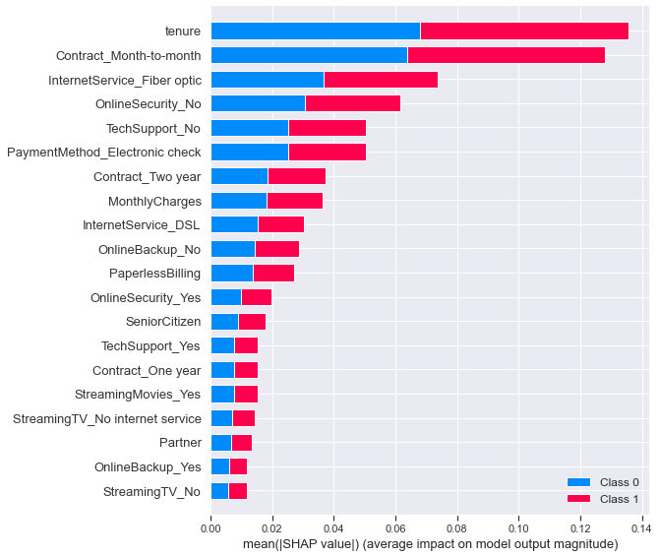
Figure 4.22: Shapley Summary plot of Random Forest Classifier Model

The feature importance for Random Forest Classifier model depicts 3 contribution values. The outstanding is MonthlyCharges with relative importance above 0.25, followed by contract-month to month close to the relative importance of 0.25 (see fig. 4.23).
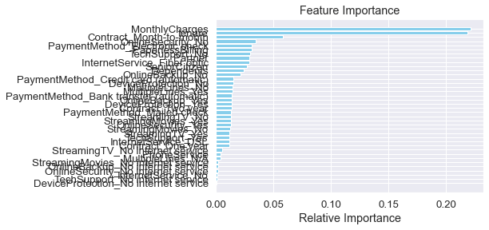 Figure 4.23: Random Forest Classifier Model Feature Importance
Fig.4.24 and 4.25 look alike. In Fig 4.24, tenure in an exponential decay curve of tenure interaction with OnlineSecurity_No is quite opposite to Fig. 4.24. The Shap dependences as shown in these figures are for tenure shap values index zero and MonthlyCharges with shap values index 1 for figure 4.25.
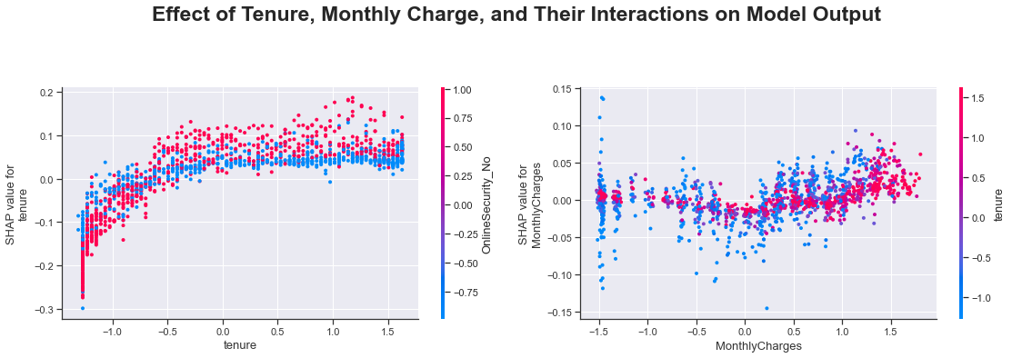
Figure 4.24: Effect of Tenure, MonthlyCharges and their interactions on model Output
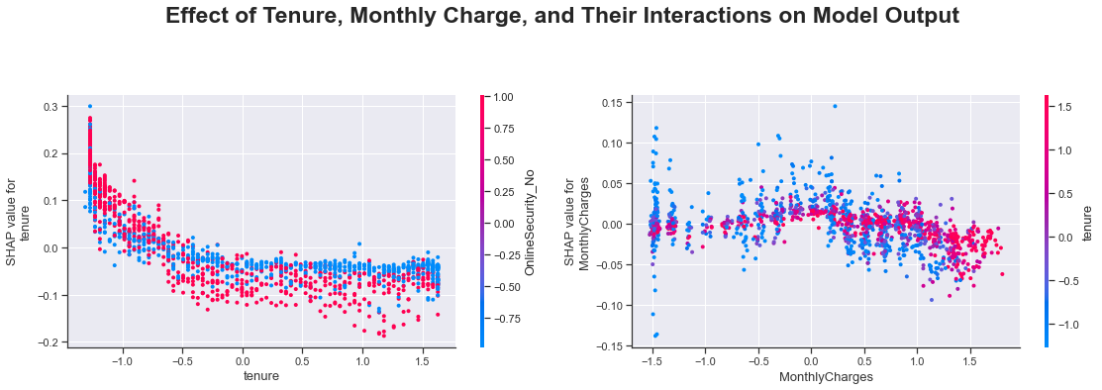
Figure 4.25: RFC Effect of Tenure Monthly Charges and interactions on model output
As shown in Fig 4.26, the shap force plot indicates at every point in the graph, how each feature contributes to the model output. The f(x) = 0.24 is the prediction where tenure and OnlineBakup_No have low impaction, and Contract_Month-to-Month and TechSupport_No have a high effect on the model prediction output.

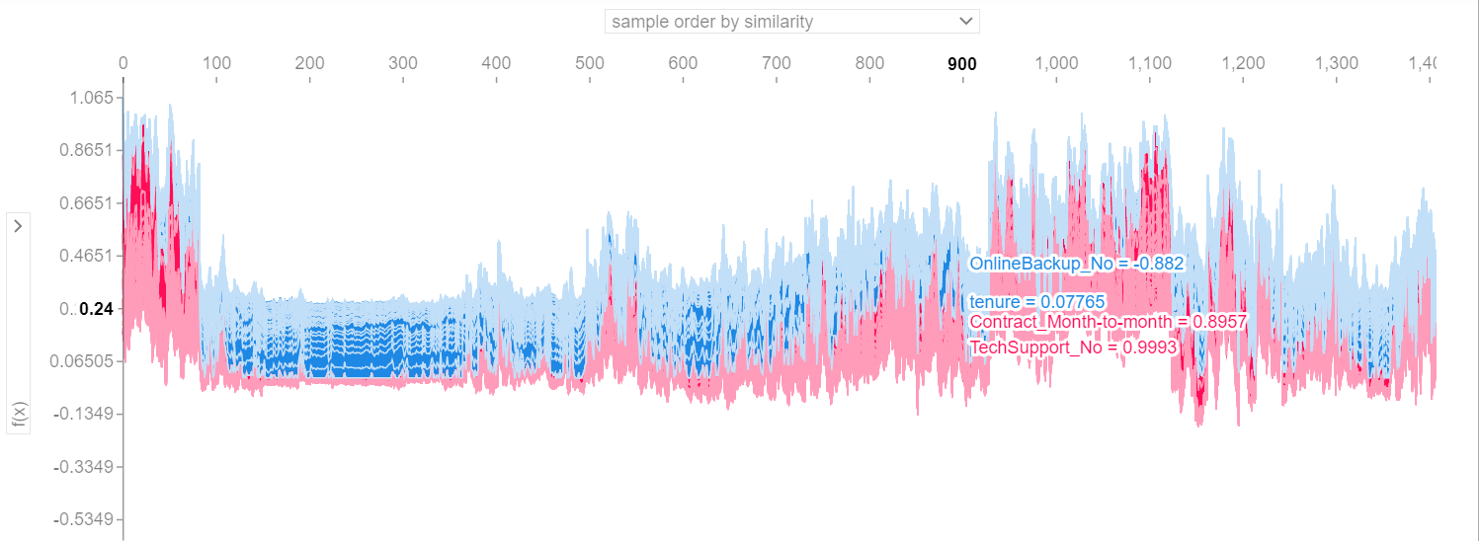
Figure 4.26: Shap force plot of the random forest classifier model output
4.4 Model Assessment
In this section, a tabular representation of how the models perform is presented. The first on the table list is XGBoost Classifier, however, the outperformance over Logistic Regression was not much. Table 4.3 is the models' assessment for all the models used in this investigation.

Model | ROC AUC | Test Accuracy | Precision | Recall | F1 Score | F2 Score
XGBC | 0.901/0.850 | 0.850 | 0.660 | 0.503 | 0.571 | 0.528
LG | 0.841/0.847 | 0.847 | 0.487 | 0.867 | 0.624 | 0.751
RFC | 1.00/0.816 | 0.816 | 0.601 | 0.452 | 0.566 | 0.476

5.0 Discussion of Results
Three Machine Learning Algorithms were utilized in this prediction of telco customer churns. Logistic Regression, Random Forest Classifier, and Extreme Gradient Boosting Classifier were employed. The purpose was to predict customers that would churn and which of these Algorithms would be best to predict the exact number of customer churns. Logistic Regression predicted 29 percent customer churn for the train set while 71 percent were non-churn for the set within the period of their contract.

The Logistic Regression predicted 72 percent non-churn and 28 percent churn for the Test data set. And has evaluation Accuracy of 72 percent and 70 percent accuracy based on the cross-val-score. The ROC AUC for the model Logistic Regression was 0.841 for the train set and 0.846 for the test set. The XGBoost Classifier shows 0.822 for training set accuracy and 0.793 for the test set. This classifier has a ROC AUC of 0.850 and is an indication of test data accuracy improvement after hyperparameter tuning with GridSearchCV. The implication is that more churn customers were predicted than in the previous prediction (751 non-churn and 284 possible churns). Other hyperparameter tuning methods can increase the performance of the XGBoost Classifier. This includes RandomizedSearchCV and HyperbandSearchCV. For the Random Forest Classifier, the algorithm demonstrated a training set accuracy of 0.997, test set accuracy of 0.781, and Cross-Val-Score of 0.79 +/- 0.03; and the ROC AUC for the test set was 0.816 and 1.00 for the training set. Applying the Confusion Matrix, after hyperparameter tuning, the test data accuracy becomes 0.77 resulting in less prediction of customer churn. (1) XGBoost Classifier: ROC AUC = 0.850, (2) Logistic Regression: ROC AUC = 0.841, (3) Random Forest Classifier: ROC AUC = 0.816. Based on the above results, the XGBoost Classifier model is presented to the organization's customer retention group to restrategize their business program. This would be an avenue for the organization to target those customers with a high propensity to churn. This would help the organization to enjoy increased revenues via its improved retention program or strategy.
5.1 Conclusion
In this investigation, three Machine Learning Algorithms were used to predict telco customer attrition or churn rate. These are Logistic Regression, Extreme Gradient Boosting Classifier, and RandomForest Classifier. Based on prediction performance, and test accuracy assessment, XGBoost Classifier is outstanding with ROC AUC of 0.850, followed by Logistic Regression with ROC AUC of 0.847, and then Random Forest Classifier with ROC AUC of 0.816. It is possible to improve the performance and results of all these models by applying Hyperparameter Tuning though they may affect both the memory storage and the processing time which are very invaluable in the computation and processing of big data.
5.2 Recommendations
XGBoost Classifier outperformed other models in the investigation.
- The Organization's customer retention group is presented with this model to restrategize their business program.
- Those customers with a high propensity to churn are targets
- Following up with incentives bonuses to help to retain those customers about to churn, will help the enterprise to enjoy increased revenues via an improved retention program or strategy

References
Aakash, Dwivedi (2019): Telecom Industry, Customer Churn Prediction Paper 177-
2290338.
Ahmad, et al (2019): Customer churn prediction in telecom using machine learning in big
data platform, Journal of Big Data, SpringerOpen Vol 6 #28 pp1 -24
Atallah M. Al.Shatnwali (2020): Predicting Customer Retention using XGBoost and
Balancing Methods. International Journal of Advanced Computer Science and
Applications Vol. 11 #7
Bryan Gregory (2018): Predicting Customer Churn: Extreme Gradient Boosting with
Temporal Data.
Igbal Hanif (2020): Implementing Extreme Gradient Boosting (XGBoost) Classifier to
improve customer churn prediction. DOI 10.4108/eai:2-8-2019-2290338.
Irfan Ullah, et al: A churn Prediction Model using Random Forest: Analysis of Machine
Learning Techniques for Churn Prediction and factor Identification in Telecom
sector, IEEE.
Lingling Yang, et al (2021): Prediction Modeling and Analysis for Telecom customer churn
in two months.
Qiannan Zhul, et al (2019): Customer churn prediction based on LASSO and Random
Forest models, IOP Conference Series: Materials Science and Engineering Vol
631, 5
Yaya Xie, et al (2009): Customer Churn prediction using improved balanced Random Forest,
Elsevier Expert Systems with Applications Vol 36, 5445 - 5449

